NOTICE TO MARINERS

West of Hebrides Waverider Buoy- Drifting, UK

22nd September 2025

The Waverider Buoy at the West of Hebrides site has started drifting on 22nd Sept.

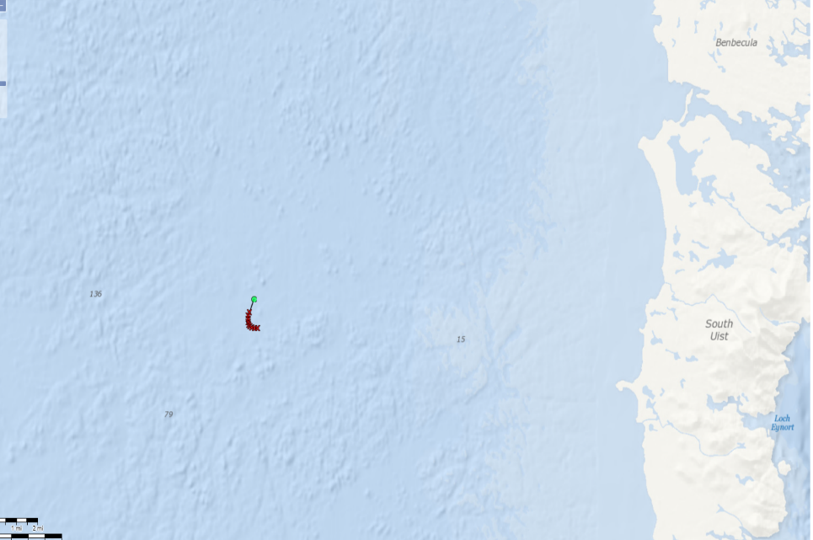

The buoy has reported its position as 57° 16.50’ N, 7° 54.58’ W at 22-Sep-2025 15:00 (UTC), which is 1.06nm away from its deployed position 57° 17.55’ N, 7° 54.83’ W.

Figure 1: Waverider (approx. 1m dia.)

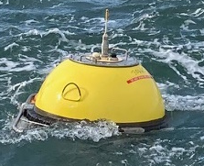

The Waverider Buoy is fitted with a yellow light exhibiting the sequence FI Y (5) 20s. The LED flashlight gives 5 flashes in 10 seconds and repeats this every 20 seconds.

Recovery operations are being planned, date TBC.
 |  | CEFAS Lowestoft Laboratory,  Pakefield Road,  Lowestoft, Suffolk NR33 0HT  Telephone : +44 (0) 1502 562244

